IKEA Dual Cape Sofa

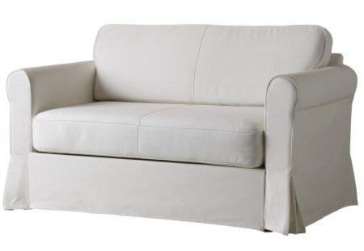

|  |
| --- |
| **DESCRIPTION** |
| Intense penetrated cushion Sofa produced by IKEA Sofa company, presents a white pitched very comfortable sofa. The extra-long back relaxes the spinal cord extra long legs on bottom provide stability for the sofa. This sofa is build in such a way that if the user needs to wash the skin of the sofa than it could be easily removed by opening zip of the sofa hidden under the long cape which is used to protect the look of the sofa. |

|  |  |  |
| --- | --- | --- |
| **Price** | **3500$** | |
| **Dimensions** | **H** x **W** x **L** | **35in x 32in x 64in** |
| **Features** | **This sofa is built for two people but three people can also sit at once which makes it perfect for family gathering.** | |
| **Finished** | **Hard Removable Skin** | |
| **Available in** | **Grey and White** | |